Apache Tomcat

- The Apache Software Foundation (ASF) is a 501(c)3 non-profit organization incorporated in the United States of America.
- The foundation was created in 1999 by a group of people that called themselves the "Apache Group".
- The name 'Apache' was chosen from respect for the Native American Apache Nation, well-known for their superior skills in warfare strategy and their inexhaustible endurance. It also makes a cute pun on "a patchy web server" -- a server made from a series of patches -- but this was not its origin.
- Apache has always been much faster than Tomcat at serving static content. The idea is to let Apache serve the static content when possible, then proxy the request back to Tomcat for Tomcat related content.
- AJP or JK is a wire protocol. It is an optimized version of the HTTP protocol to allow a standalone web server such as Apache talk to Tomcat.
  - The Apache JServ Protocol (AJP) is a binary protocol that can conduct inbound requests from a web server through to an application server that sits behind the web server. It also supports some monitoring in terms of the web server being able to ping the application server. AJP is typically used in a load balanced deployment where one or more front-end web servers feed requests into one or more application servers.

- Catalina is the Java Engine (JRE / JVM) that's built into Tomcat and provides an environment in which Servlets can be run.
- Coyote is the HTTP connector that's built into Tomcat and provides Tomcat with an interface that browsers can connect to.
- Jasper is the Java Server pages handler in Tomcat; internally, it deals with any compiling that's neccessary, and converts JSPs into Servlets for Catalina to handle.

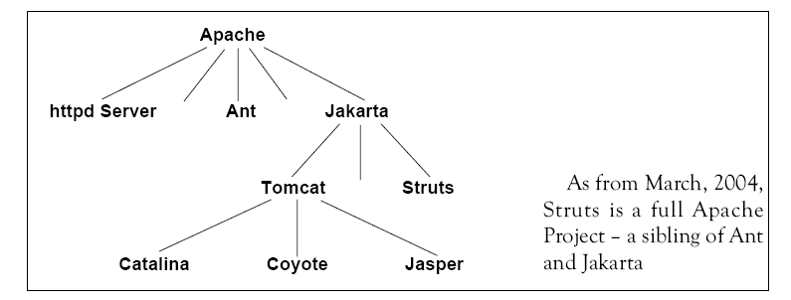
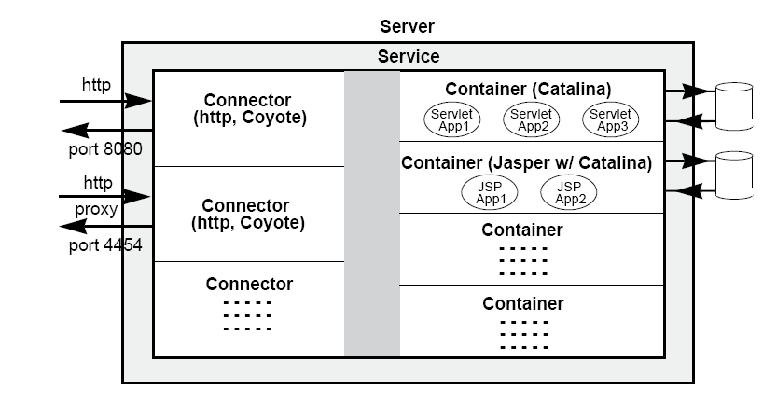

Apache versus Tomcat

Apache | Tomcat
Apache is a web server. | Tomcat is an application server.
The Apache server is written in C. | The application server end is generally written in Java.
Apache can server static content (HTML, images, CSS, PDFs, etc...) a lot faster than Tomcat can. | Slower than Apache in serving static contents. and tomcat only for serving dynamic web content.
Apache has the capability of reverse proxying, allowing you to 'plug in' one or more web applications running on one or more Tomcat instances in one URL space. | No such facility.
Apache can be used as a load balancer over multiple tomcat instances. | No such facility.
Apache has a large amount of interesting plug-ins that might be useful for your website. | We can create such plug-in, but no need to reinvent the wheel again as they are provided by Apache itself.
Apache HTTP Server 2.2.13 is the best available version. [Refer:http://httpd.apache.org/download.cgi]
Documantation:
http://httpd.apache.org/docs/2.2/

- Different versions of Apache Tomcat are available for different versions of
- the Servlet and JSP specifications. The mapping between the specifications and the respective Apache Tomcat versions is:

Servlet/JSP Spec | Apache Tomcat version
2.5/2.1 | 6.0.x
2.4/2.0 | 5.5.x
2.3/1.2 | 4.1.x
2.2/1.1 | 3.3.x (archived)

Reference:
- http://tomcat.apache.org
- http://httpd.apache.org/docs/2.2/glossary.html
- http://www.it.uom.gr/teaching/applicationsIT_1/lectures/apache/sld010.htm
- http://wiki.apache.org/tomcat/FAQ/Connectors

